Never doubt that a small group of thoughtful, committed citizens can change the world; indeed, it's the only thing that ever has….
Margaret Mead

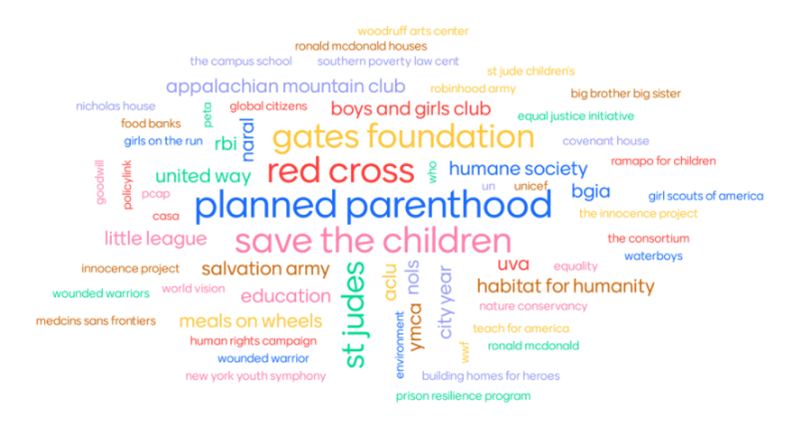
Changing the world is not easy but as Margaret Mead alludes to it can be done. Without doubt all business enterprises can change the world but the sphere of nonprofits is committed to this. Not for profit organizations run the gamut from churches and professional societies to schools, museums, and social service organizations. This course focuses on nonprofits in the social sector and the arts and is designed to provide an overview of this sector in the economy. The course is designed to examine the scope and the diversity of nonprofit organizations, the unique governance, communications, and financing structures inherent in them, and to highlight the innovative and creative opportunities available in them. One goal is to appreciate how your business skills can add value to the growth and success of these socially important organizations. The course culminates with small groups designing nonprofits with “shark tank” class session to pick the best of the class.

Academic Objectives of the Course
- Understand the similarities/differences in how nonprofits operate compared to for profit organizations.
- Understand the challenges faced by non-profits in an increasingly competitive world.
- Provide a fundamental background for future business leaders to prepare them to offer service in the non-profit world as board members.

Each class will start with a case with guests to provide expertise from different types of non-profits.
Past Guests
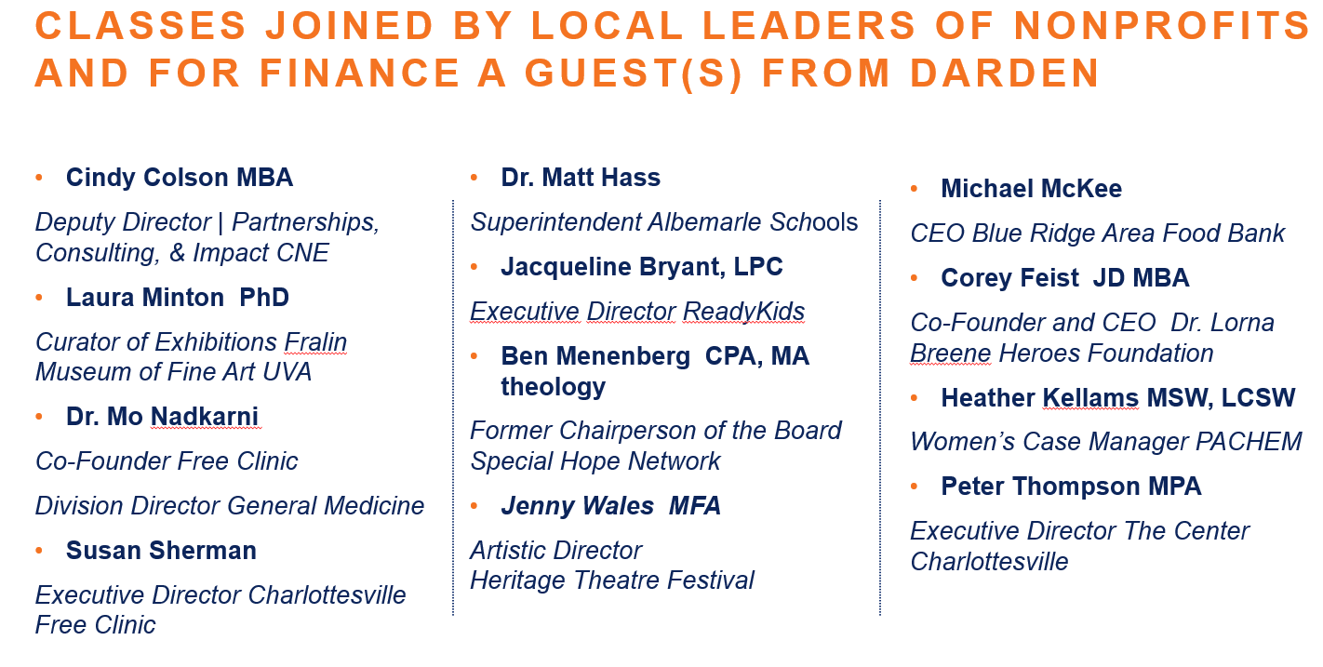
In Class participation 35%
I grade on a 3 point scale. 1 point for attending class, 1 point for contribution and another point if you contribute in a significant way.

Discussion questions write up. 15%
During the course you will be assigned 2 set of discussion questions from the case for the day to write-up (1-2 pages). The questions are outlined in the daily calendar and will be assigned in canvas. They are due by 7 pm the day before class.
Group Project(s) 50%
The group projects will be will be conducted with 4-6 students in each group. Groups will be randomly assigned after add drop is over. There are three parts for this assignment:

Leading a discussion with the Guests (10%) For guests we will devote 25 minutes for Q&A. Each group will prepare some questions and then lead the discussion. This assignment will coincide with your discussion questions write up. Questions need to be posted in Canvas by 5 pm the day before class.

Design a balanced scorecard for a Nonprofit (10%) A brief group project to design a balanced scorecard for a Nonprofit serving housing needs (Interfaith partnership for the homeless). Read the case and meet with your group to design a balanced scorecard.

In class we will discuss the case and then each group will present their scorecard (2 or 3 slides).

Design a new Not-for-Profit (30%): Identify a social need or cause and design a not-for-profit solution. You may choose any sector of nonprofits for your project. Your presentation should be directed towards a group of investors willing to fund a non-profit with $200,000 to kick start the Non Profit. The class will have “$600,000” to divide among three “winners”. The goal is to convince the class why your project should be funded.

