“You do not rise to the level of your goals. You fall to the level of your systems.”
James Clear in Atomic Habits

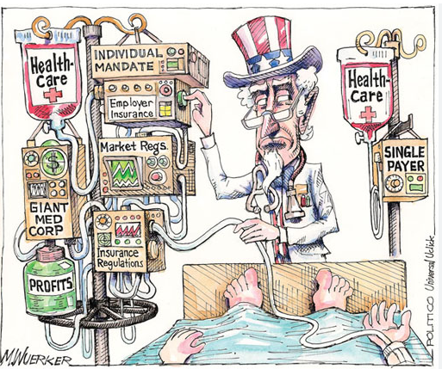
There are many challenges in the health care industry and this course will focus on the innovation in the different systems that the Health care industry is using to solve its problems. No previous professional experience in the health care sector is required and you do not need to have taken the challenges in Health care course to take this class (plenty of background material is made available). The emphasis on the cases and class discussions will be on evaluating the current approaches and considering other solutions to the challenges that exist.

Academic Objectives of the Course
- Evaluate current innovations in the health sector.
- Understand how solutions in the health sector may differ from other businesses.
- Consider how business solutions in other areas could provide value in health care.

Most classes will start with a case with guest speakers to provide additional expertise. In 3 classes the entire time will be devoted to guests who will discuss the following:
- Growth investing in the health sector Sal Rais MD MBA T Rowe Price
- Venture Capital in Pharma Jill Carroll Principal SR One
- Innovating and solving problems via consulting Vivian Riefberg MBA

Prior Guests
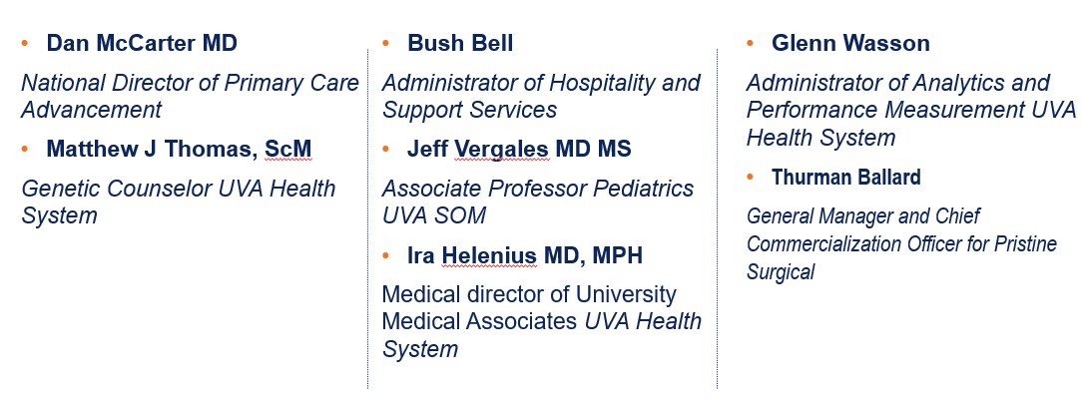

In Class participation 35%
I grade on a 3 point scale. 1 point for attending class, 1 point for contribution and another point if you contribute in a significant way.

Discussion questions write up (INDIVIDUAL). 15%
During the course you will be assigned 2 sets of discussion questions from the case for the day to write-up (1-2 pages). The questions are outlined in the daily calendar and will be assigned in canvas.

Group Project(s) 50%
The group projects will be will be conducted with 6-7 students in each group. Groups will be randomly assigned after add drop is over. There are three parts for this assignment:

Leading a discussion with the Guests (10%) For guests we will devote 25 minutes for Q&A. Each group will prepare some questions and then lead the discussion. This assignment will coincide with your discussion questions write up. Questions need to be posted in Canvas by 5 pm the day before class.

Design a Value based payment system (10%) a very brief group project to design a value based payment system treatment of low back pain. Read the case and meet with your group to design a value based payment system. In class we will discuss the case and then each group will present their plan.

SHARK TANK: designing a new healthcare innovation (30%): Identify a need/problem or cause in the health care sector and design an innovative business solution. Please select the area in health care IT, supply chain, health care delivery, etc.) and a name for your proposal by the end of the second week of class and fill this in on the google sheet. This will be in lieu of a Final Exam. Your presentation will be directed towards a group of “investors” willing to fund a healthcare innovation with $1,000,000. There will be “$3,000,000” to divide among three who will be funded. The goal is to convince the investors why your project should be funded.

